2021 Portage Crossing Manukau Harbour Dash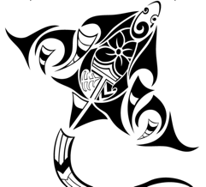

Come back to the water, so we can again be as one
Come back to enjoy the ocean, to play where we have fun
Come back to enjoy whānau, friends, community on our waka
Come back to where we feel whole on the water

To all our Waka community, we welcome you back to our Harbour!

Portage Crossing Canoe Club Incorporated is hosting a nice low key, fun community race to be held in Auckland on the Manukau Harbour on Saturday 4th September 2021

IMPORTANT INFORMATION AND DATES

VERY IMPORTANT:
- Monday 30th August – ENTRIES CLOSE. NO LATE ENTRIES, NO RACE DAY ENTRIES AT ALL DUE TO COVID CONTACT TRACING PROTOCOLS AND DATA ADMINISTRATIVE TASKS FOR TIME KEEPING Just makes it a whole lot harder for our volunteer time keepers, so please be organised with your entry. Just make the decision and enter now.
- Wednesday 1st September - ROSTER CLOSES
- Saturday 4th September - RACE DAY
- Sunday 5th September - BACK UP RACE DAY Keep an eye on the Portage Crossing Facebook page: https://www.facebook.com/Portage-Crossing-Outrigger-Canoe-Club-995412633873039/

COVID-19 REQUIREMENTS:
- All Paddlers MUST be registered through the WANZ Website.
- All visitors MUST Sign In at our Registration table (or at least one member of each family).
- No sharing of personal equipment.
- All Clubs MUST provide Sanitizer for Waka and Equipment.

PROGRAMME - SATURDAY 4TH SEPTEMBER

0600 Registration table opens at Allan Park, Kiwi Esplanade, Māngere Bridge
0600-0700 Safety Checks to be completed at the race start venue. Compulsory water
safety gear is standard. *NO RACING WITHOUT THE REQUIRED SAFETY GEAR.
0700 Karakia
Race Briefing Long Course/ Short Course variation
0730 Race Start - All W6 Divisions (incl. Novice)
*All novice paddlers or non-competent swimmers must wear PFDs
0900-1030 Hot kai/food will be provided for all paddlers with a meal ticket. Your meal ticket will be in the race pack you pick up when you sign in at Registration.
Waste Management: We encourage people to bring their own plate/bowl, cutlery and keep cup, to minimize waste. Please take your own rubbish home with you when you leave.

ENTRY FEES

8km Short Course Fee $15.00 per paddler - includes kai/ food ticket
16km Long Course Fee $20.00 per paddler - includes kai/ food ticket

(PLEASE NOTE: No show, no refund)

PAYMENT INSTRUCTIONS
Please deposit or transfer bulk team payment, i.e. 6 people all together or, preferred, whole club payment (easier to trace) NO individual per person payment please. Many thanks.
Payments to: Portage Crossing 12 3019 0035274 00
Reference Team Name; or for bulk club payments reference Club Name and number of teams

RACE DISTANCES AND COURSES
All paddlers to arrive and register on time, so we can start on time to catch the tide. The Manukau Harbour is tidal and the tide moves fast. We don’t want to be beached and have a mud run on the way in.
Both race courses are in the Onehunga-Māngere Bridge leg of the Manukau Harbour. Both race courses are very simple, straightforward return courses. Safe for most weather conditions as they are quite sheltered. If the weather turns dangerous and winds become dangerously high, the race will be called off and moved to the following day, weather permitting. Please ensure you save Sunday 5th August just in case. We want to provide all paddlers with an enjoyable, safe experience.

Distances & Divisions - 8km and 16km

W6 8km Short Course for Juniors, Adults and Novices:
J16, J19, Open, Master and Senior Master Men, Women & Mixed

These catagories will apply only if there are three or more teams in that division. If there are less than three teams in a division, the team/s will be merged with another division.

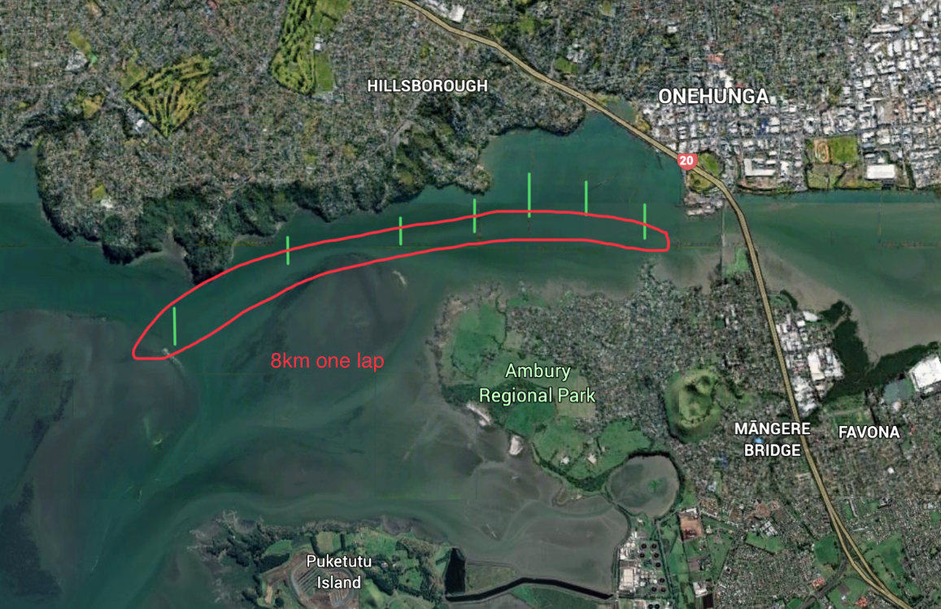
W6 16km Long Course for Juniors and Adults
J16, J19, Open, Master and Senior Master Men, Women & Mixed

The above catagories will apply only if there are three or more teams in that division. If there are less than three teams in a division, the team/s will be merged with another division.

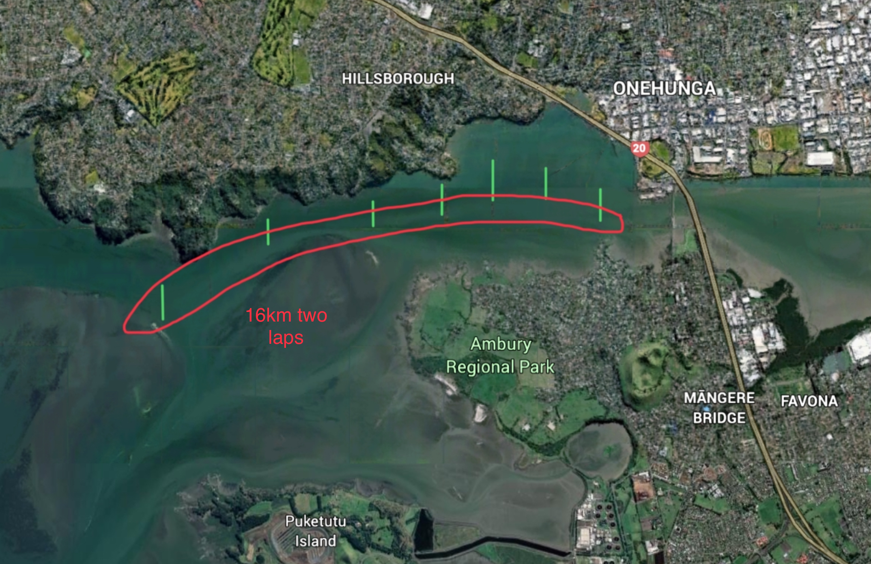

QUESTIONS AND ENQUIRIES

For any further information, including waka hirage, please email portagecrossing@gmail.com or message our Facebook Page @Portage Crossing Canoe Club:
https://www.facebook.com/Portage-Crossing-Outrigger-Canoe-Club-995412633873039/

We look forward to seeing all our waka whānau there!

Mahalo
